TREE MENU Navigation

## Understand the XMLjqueryReaderSample.html file

The tree menu can be formed by XML source. xml source is stored in a variable like xmlDoc1,xmlDoc2 which is loaded into an xmlArray. The menu should be formed from xmlArray.

This functionality to be implemented in home.html

When clicking on Menu Bar icon the menu should read from the xmlArray and display the menu for each array element sequentially.

There should be a separator between each array element display.

## XML String Conversion

In the home.html by using different function a Tree menu structure can be dynamically formed. which can be previewed by invoking preview button.

The objective is to generate an xml content for this tree menu structure whose value can be stored in an input box. This xml content should be served as an input source for the following:

a. For Preview function which is currently working.

b. For loading the Tree Configuration Structure

2.1 There is an input box in home.html named xmlInput - the type will be converted to hidden once the testing is completed.

2.2 xmlDoc2 variable reads the content from xmltInput.text

2.2 During the page load time the tree section should read from this xmlDoc2 variable and load the tree.

2.3 When the xmlInput javascript variable is modified by editing manually, The Tree should be formed accordingly on this page.

2.4 When clicking the preview button, preview window should render the menu reading from the xmlString javascript variable.

2.5 When the tree is modified xml content will be generated and xmlInput text variable should be updated to reflect the changes.

## Menu Bar Navigation: Publish Function

1. To replace the Menu Bar icon to same icon used in Preview Menu window.
2. When Menu icon is clicked(or Mouseover), Menu should read from xmlArray variable and render the menu same as it is displayed in the Preview Section.
3. Dropdown should come only when mouse over MENU icon. Now it is coming in the whole section.

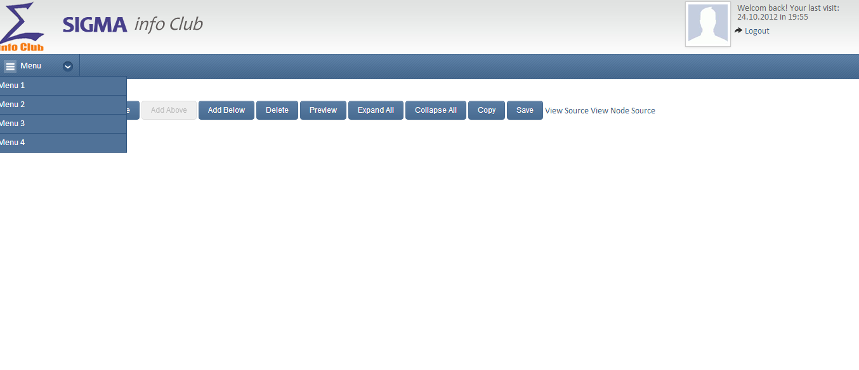

1. Down Arrow to be removed

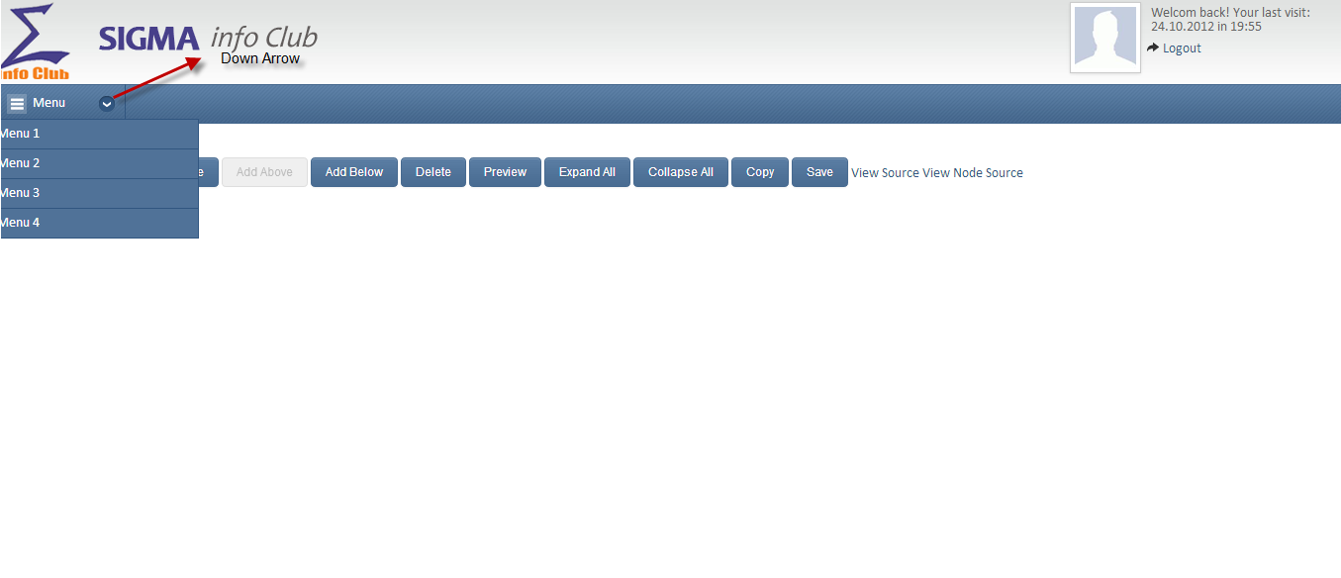

When Menu Expands it should open exactly like preview screen.

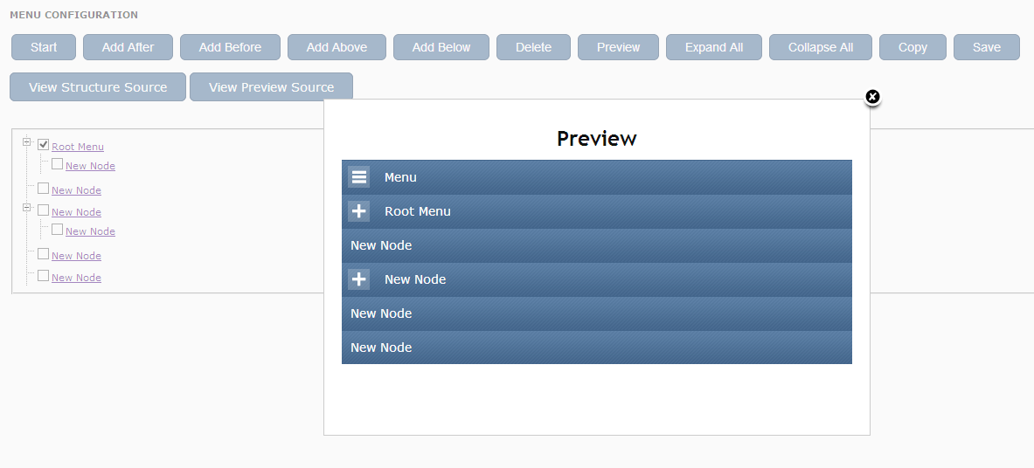

1. Make the bar Collapsible. Put an collapsible icon here on the right hand side corner.
2. Give ideas to make the layout more presentable.
3. Browser compatibility( Internet Explorer IE7-7 to 12, Google Chrome, Firefox, Safari).
4. It should work in Mobile as well as Desktop screen. Adaptive UI (Mobile as well as Desktop). Android & Apple device, Responsive UI, ipad/iphone/tabs
5. Clean the folder by removing unwanted files and code. Remove all the unwanted files from folder which are not used.

Remove unwanted function or code which are not used.

11. Create a document for all the js CSS function been used. Source Code to be handover such a way it is scalable and server side programming can be implemented.

**Appendix**

<http://www.4guysfromrolla.com/webtech/072501-1.shtml>

xmlString="

<init type="root">

<admin type="folder" value="Administration">

<userManagement type="folder" value="User Management">

<userRegister type="leaf" value="User Registration" url="userRegistration.do?param=init"/>

<userManagement type="leaf" value="User Management" url="userManagement.do?param=init"/>

<Reset type="leaf" value="Reset Password" url="resetPassword.do"/>

</userManagement>

<roleManagement type="leaf" value="Role Management" url="roleManagement.do"/>

<menuConfig type="leaf" value="Menu Configuration" url="menuConfig.do"/>

</admin>

</init>

";